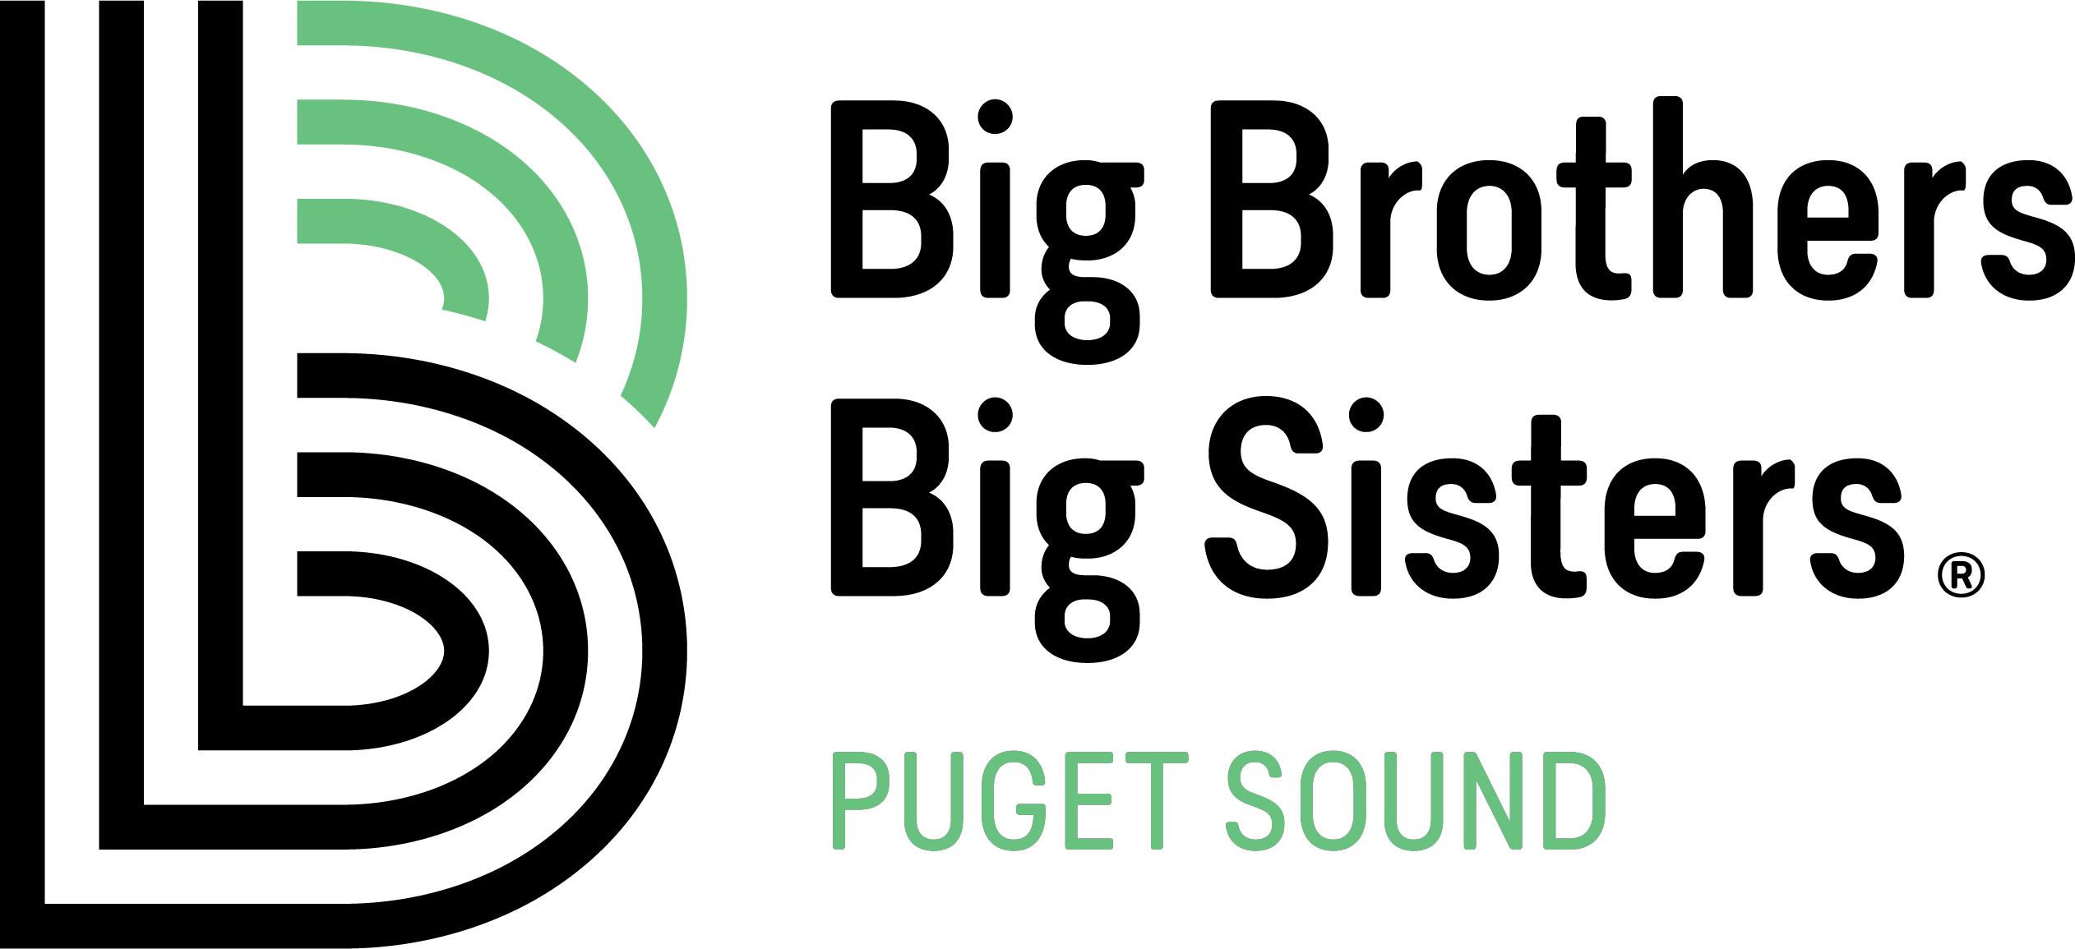

JOB TITLE: Program Coordinator – Career Connected
FLSA STATUS: Non-Exempt, Full Time
DEPARTMENT: Career Connected - Site Based Programming
LOCATION: Seattle
PAY RANGE: $18.00-20.50/hour DOE + Generous benefits including vacation and sick leave, 100% employer paid medical, dental, vision, and long term disability for employees, 401 (k) employer match and EAP
MANAGES: N/A

REPORTS TO: Program Manager – Career Connected

LAST REVIEWED: September 2019

Our Mission: To create and support one-to-one mentoring relationships that ignite the power and promise of youth.

Each employee in Big Brothers Big Sisters of Puget Sound helps to extend the mission of the agency in particular ways as outlined in the position description. The essential functions of the position include, but are not limited to the following:

JOB SUMMARY:
Are you a person who is passionate about working closely with students? Are you committed to equity for students? Do you thrive on thinking out-of-the-box? Do you work well in a team environment to meet goals and objectives? At Big Brothers Big Sisters of Puget Sound our team strives to sponsor and promote innovative partnerships between youth, adults and the community. Our Career Connected programs pair youth from select schools with mentors at select partner corporations. This Program Coordinator will facilitate our Career Connected programing in the Greater Seattle Area and/or Bellevue.

The Career Connected Program Coordinator will influence educational and career success by working with elementary/middle/high school aged students, administrators, and community and corporate partners. You will connect students with positive adult mentors who can transform their futures. By maintaining contact with matched pairs, you will ensure successful and viable ongoing relationships. The Program Coordinator will also participate in recruiting, interviewing and training volunteer mentors and students. The Program Coordinator should possess the drive to meet or exceed goals and build capacity for future growth.

Essential Job Functions and Accountabilities:
Program Development and Implementation Responsibilities
- Plan and facilitate monthly or bi-weekly sessions for in-person meetings with students and mentors.
- Identify the needs for and conduct outreach for new volunteers and children. Collaborate with Outreach team to ensure enough volunteer mentors are secured to match each student enrolled.
- Manage and support a caseload through entire process.
- Lead orientation and training sessions for teachers, volunteer mentors, families, students, and businesses.
- Organize and assess available student data.
- Compile monthly outcome reports for identified stakeholders: schools, corporate partners, and agency management and Board.
- Maintain documentation to assure accountability, effectiveness, and efficiency.
- Collect data of clients enrolled to include outcomes, attendance, disciplinary issues, and grades.
- Develop and maintain on-going relationships with designated corporate partners and BBBSPS, including regular communication and problem-solving.
- Communicate and coordinate with school personnel to establish mentoring program within school; work with school staff to recruit youth to participate, and assess individual match needs as necessary.
- Conduct client enrollments including child interviews, child safety education, and enrollment processes.
- Determine matches and facilitate match meetings in accordance with the volunteer, youth, and teacher schedules. Relay match information to parent/guardian.
- Facilitate contact between youth and volunteer, particularly during summer months.
- Host year-end match appreciation party at each school site on caseload. Create and distribute invitations to matches, procure food items, plan appropriate activities.
- Participate in required agency trainings/on-going professional development/coaching in the areas of:
  - Race and Equity
  - LGBTQ Competency and Support Strategies
  - Youth Development Best Practices
  - Trauma Informed Practices
- Apply the practices and principles attained in your BBBSPS trainings/on-going professional development/coaching to all mentors, mentees, and families.

Enrollment Responsibilities
- Conduct volunteer enrollments, including: individual orientations, interviews, and completion of any other enrollment processes.
- Conduct client enrollments in their home including parent/guardian and child interviews, child safety education and enrollment processes. Assess and refer families for alternative or additional services as needed.
- Address personal and potentially sensitive topics when conducting interviews, such as sexual orientation, gender identity, and history of abuse or other trauma.
- Review all enrollment information and assessments and make recommendations for participation in the program based on this information.

Agency Support Responsibilities
- Establish, monitor and meet goals for new match growth, match length, support contact compliance, and customer satisfaction.
- Coordinate with other departments to identify possible partners and partnerships, staff and promote agency events, and provide support for other efforts as necessary.
- Utilize educational opportunities and related resources to improve agency service.
- Promote and maintain cooperative working relationships with other community organizations.
- Other duties as assigned by the Program Manager or the Vice President of Programs.

JOB QUALIFICATIONS:
- Bachelor's degree is required for this position
- Fluent in Spanish not required, but preferred
- Access to reliable automobile, valid driver’s license, auto insurance required
- Willingness and ability to support the organization’s efforts to enhance diversity, equity and inclusion. Must be comfortable working with a range of races, gender identities, sexual orientations, religious beliefs, languages, and socioeconomic backgrounds.
- Understanding of child development and family dynamics
- Understanding of issues/barriers that impact children and families from underserved populations
- Effective collaboration skills with internal and external colleagues
- Able to collect meaningful data and draw solid conclusions
- Proficient in Microsoft Word, Excel and Outlook
- Able to work independently exercising good judgment, decision-making and problem-solving skills
- Able to succeed in a fast-paced environment required.
- Able to work with confidential information required
- Available to work evenings and weekends as needed
- Excellent oral and written communication skills reflecting solid customer service both in-person and via the telephone

COMPETENCIES NEEDED TO BE SUCCESSFUL WITHIN OUR ORGANIZATION:
We seek to hire for, and further develop with each employee, the following competencies that we have identified as critical to success for individual employees and for achievement of the BBBSPS mission.
Core Competencies
- Accountability / Workload Management
- Customer Service Orientation
- Growth Mindset, Adaptability
- Cultural Sensitivity
- Collaboration
- Expertise in Area of Focus
Leadership Competencies
- Develops & Motivates Others
- External Relationship Builder
- Team Effectiveness
- Emotional Intelligence
- Organizational Growth Orientation
- Problem-Solving
- Initiative & Results Driven

WORK ENVIRONMENT:
The environmental conditions described are representative of those that must be met by an employee to successfully perform the functions of the job. Reasonable accommodations may be made to enable individuals with disabilities to perform the functions.
- Routine office environment as well as varied program locations (schools and/or businesses).
- Frequent independent travel.
- Physical demands: While performing duties of job, employee is occasionally required to stand; walk; sit; reach with hands and arms; talk and hear. Employee must occasionally lift and/or move up to 25 lbs. Specific vision abilities required by the job include close vision, distance vision, color vision, peripheral vision, depth perception, and the ability to adjust focus.
- Work environment: The noise level in the work environment is usually moderate.
- Phone time: 50% of work will be spent on the phone contacting volunteers, parent/guardians, and Littles.

The above statements are intended to describe the general nature and level of work being performed by individuals assigned to this position. They are not intended to be an exhaustive list of all duties, responsibilities, and required skills. Job descriptions may be subject to change to meet the needs of the organization. Management retains the discretion to add or to change the duties of the position at any time.
Your employment with BBBSPS is “at will,” meaning that either you or BBBSPS may end your employment at any time and with or without cause.

Equal Employment Opportunity
BBBSPS is committed to the principle of equal employment opportunity for all qualified individuals. All employment decisions are based on business needs, job requirements and individual qualifications, without regard to race, color, religion, national, social or ethnic origin, sex (including pregnancy), age, physical, mental or sensory disability, sexual orientation, gender identity and/or expression, marital, civil union or domestic partnership status, past or present military service, family medical history or genetic information, family or parental status, or any other status protected by the laws or regulations in the locations where we operate.

Americans with Disabilities Act
Applicants as well as employees who are or become disabled must be able to perform the essential duties & responsibilities either unaided or with reasonable accommodation. The organization shall determine reasonable accommodation on a case-by-case basis in accordance with applicable law.

To Apply: Please submit a cover letter and resume to jobs@bbbsps.org with “Program Coordinator – Career Connected” in the subject line

